# CSCI 2410 Introduction to Data Analytics Using Python Homework Assignment #1

**HW Programming #1: Using Python**

Tasks: Install Python and its Library Packages, and practice with simple Python programming

Assignment Instructions:

1. **[10%]** Refer the ‘2410 lecture notes - Install Python Package’ for downloading and installing the Python language, the PyCharm, and the needed Library Packages

**Done**

1. **[20%]** Check and print the version numbers of the Python and the Library you have installed using PyCharm project setting and using Python Console of PyCharm.

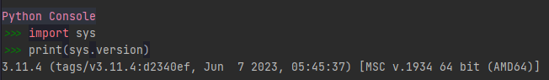

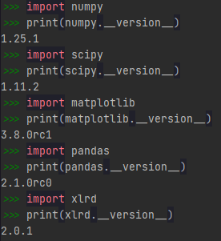

1. **[40%]** Write a program in PyCharm (Refer to lecture notes and online resources for how to create Python projects and .py files) that does the following tasks in order:
   1. Asks the user to enter a positive real number “x”

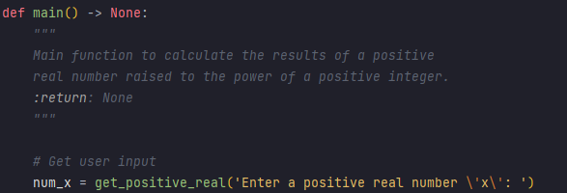

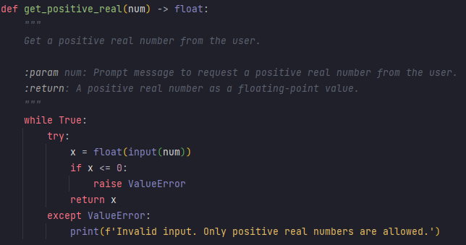

This invokes the get_positive_real function to validate the user's input.

* 1. Asks the user to enter a positive integer number “y”

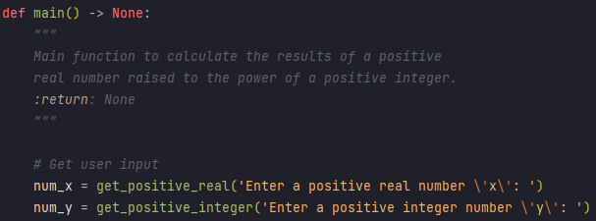

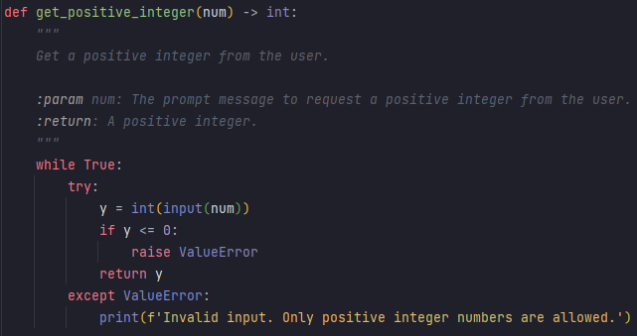

This invokes the get_positive_integer function to validate the user's input.

* 1. Calculates and prints out number “z” which is the result of “x” raised to the power of “y”.



* 1. Calculates and Prints out the log2x and log2y.

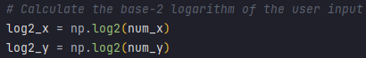

1. **[30%]** Your program should contain.
   1. Proper input checking and validity

Done

* 1. Proper output formatting and validity

Done

**Test and Run Examples with Annotations**

1. Enter a positive real number 'x': 3.5- User is prompted to enter a positive real number, and they input 3.5 as 'x'.

Test Case 1: Valid Inputs

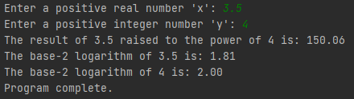

2. Enter a positive integer number 'y': 4- User is prompted to enter a positive integer number 'y', and they input 4.

3. The result of 3.5 raised to the power of 4 is: 150.06- The program calculates 3.5 raised to the power of 4, which is 150.06.

4. The base-2 logarithm of 3.5 is: 1.81- The program calculates the base-2 logarithm of 3.5, resulting in 1.81.

Decimals were rounded to 2 decimal places for clarity.

5. The base-2 logarithm of 4 is: 2.00- The program calculates the base-2 logarithm of 4, resulting in 2.00.

User is prompted to enter a positive real number, but they input -3.5, which is not positive. The program responds with an error message.

Test Case 2: Invalid ‘x’ Inputs

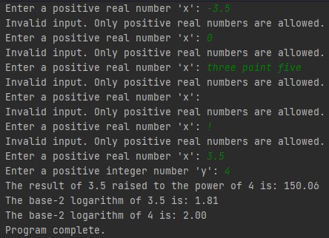

User is prompted to enter a positive real number, but they input 0, which is not positive. The program responds with an error message.

User is prompted to enter a positive real number, and they successfully input 3.5 as 'x'.

User is prompted to enter a positive real number, but they input a special character ("!"). The program responds with an error message.

User is prompted to enter a positive real number, but they leave the input field empty. The program responds with an error message.

User is prompted to enter a positive real number, but they input text ("three point five") instead. The program responds with an error message.

Note: A positive integer is also allowed to be the input for the real number.

Test Case 3: Invalid ‘y’ Inputs

User is prompted to enter a positive integer number, but they input -4, which is not positive. The program responds with an error message.

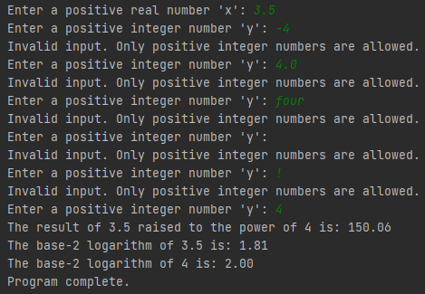

User is prompted to enter a positive integer number, and they successfully input 4 as 'y'.

User is prompted to enter a positive integer number, but they input a special character ("!"). The program responds with an error message.

User is prompted to enter a positive integer number, but they leave the input field empty. The program responds with an error message.

User is prompted to enter a positive integer number, but they input text ("four") instead. The program responds with an error message.

User is prompted to enter a positive integer number, but they input a decimal number (4.0) instead. The program responds with an error message.

1. Discussion page.
2. Hardware and software used by your program.

I completed this assignment using my personal computer with PyCharm Professional Version: 2023.2.1.

1. Features of your program, e.g., data structures, algorithms, programming styles, etc.

The provided code features the following aspects:

**Data Structures:**

- The code primarily utilizes Python's built-in data structures, such as floats and integers, to handle user inputs and results.

**Algorithms:**

- The program incorporates mathematical operations to calculate the result of raising a positive real number to a positive integer power. It uses NumPy's `np.power()` function for exponentiation and `np.log2()` for logarithmic calculations.

**Programming Styles:**

- The code follows a structured and modular approach with functions for input validation (`get_positive_real` and `get_positive_integer`) and a main function (`main`) for program execution. This promotes code readability and modularity.

**Error Handling:**

- Robust error handling is implemented to handle invalid user inputs, ensuring that the program raises `ValueError` exceptions when necessary. This enhances the program's ability to manage unexpected input gracefully.

**Input/Output Handling:**

- The program interacts with the user by displaying prompts for input and providing well-formatted output. It uses formatted string literals (f-strings) to display results with appropriate precision.

**External Libraries or Modules:**

- The code utilizes the NumPy library (`import numpy as np`) for mathematical computations, specifically for exponentiation and logarithmic calculations.

**Testing and Validation:**

- The program has been designed to request and validate user input for positive real numbers and positive integers, ensuring the correctness of inputs.

1. Problems you encountered during your work.

None.

1. Assigned discussion problems if there is any.

None.

1. Fill in the following table and submit it along with your above submissions.

|  |  |  |  |
| --- | --- | --- | --- |
| Total (approximate) time spent on the assignment | 15 hours | Total (approximate) time for the correction part | 2 hours |
| Problems and difficulties encountered | It took me a while because I haven't coded in Python for weeks. | | |
| Reflections (good and bad) on the assignment | The coding aspect is fine, but having to annotate in the Word file was time-consuming. | | |
| Any comments and suggestions | None | | |